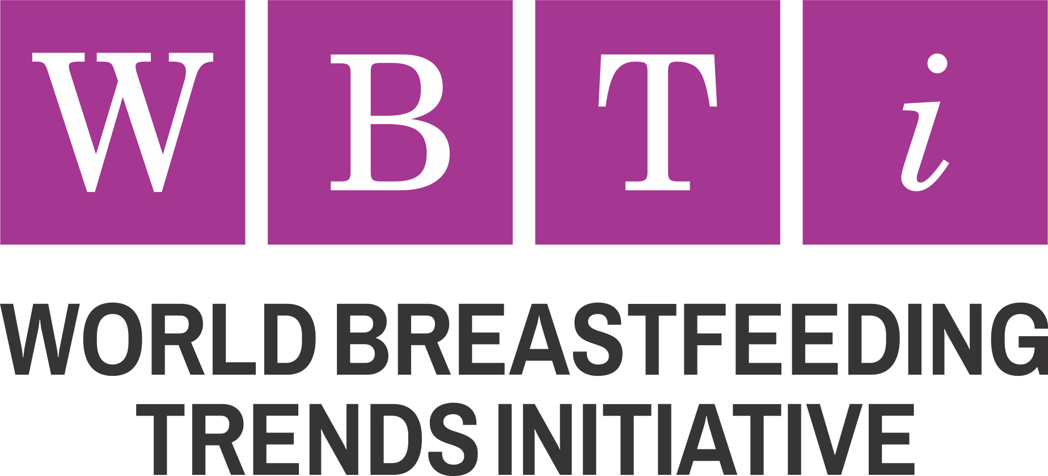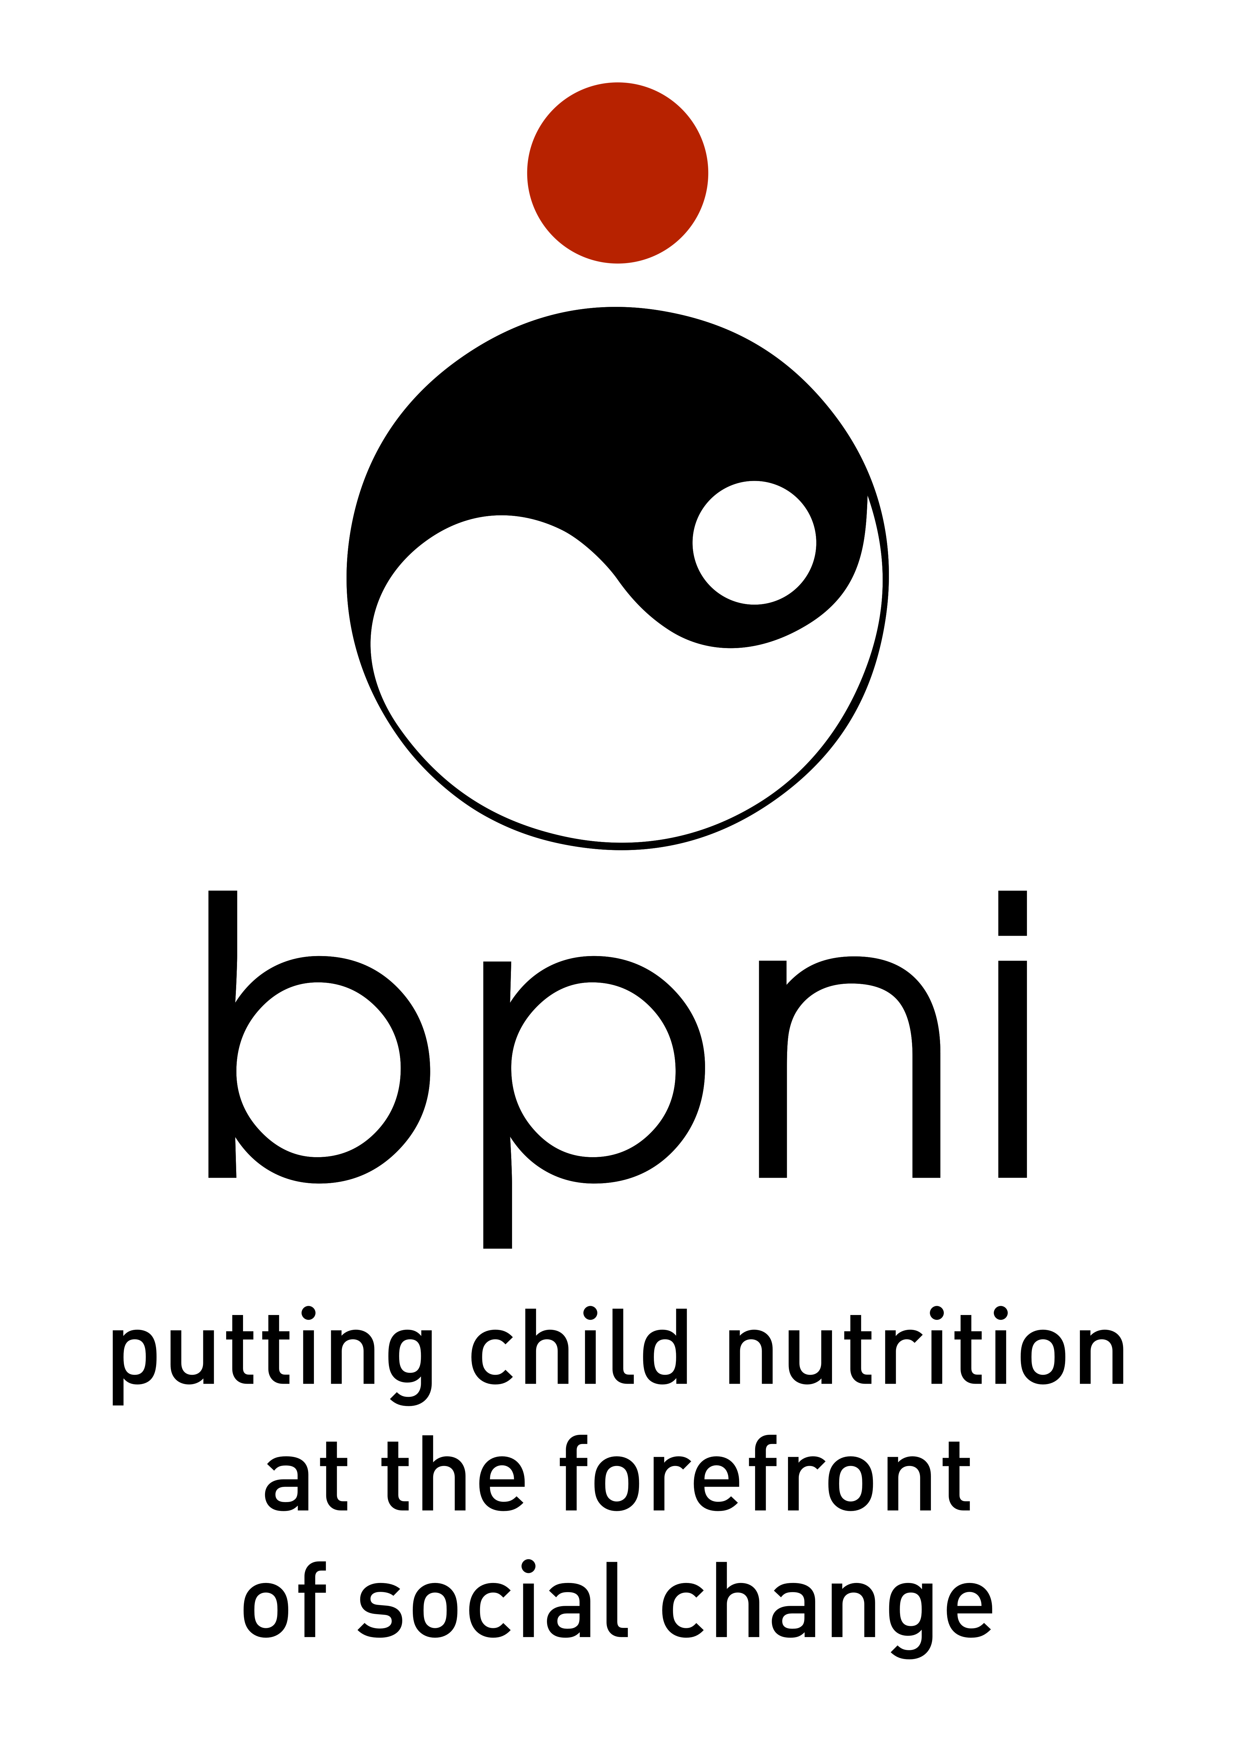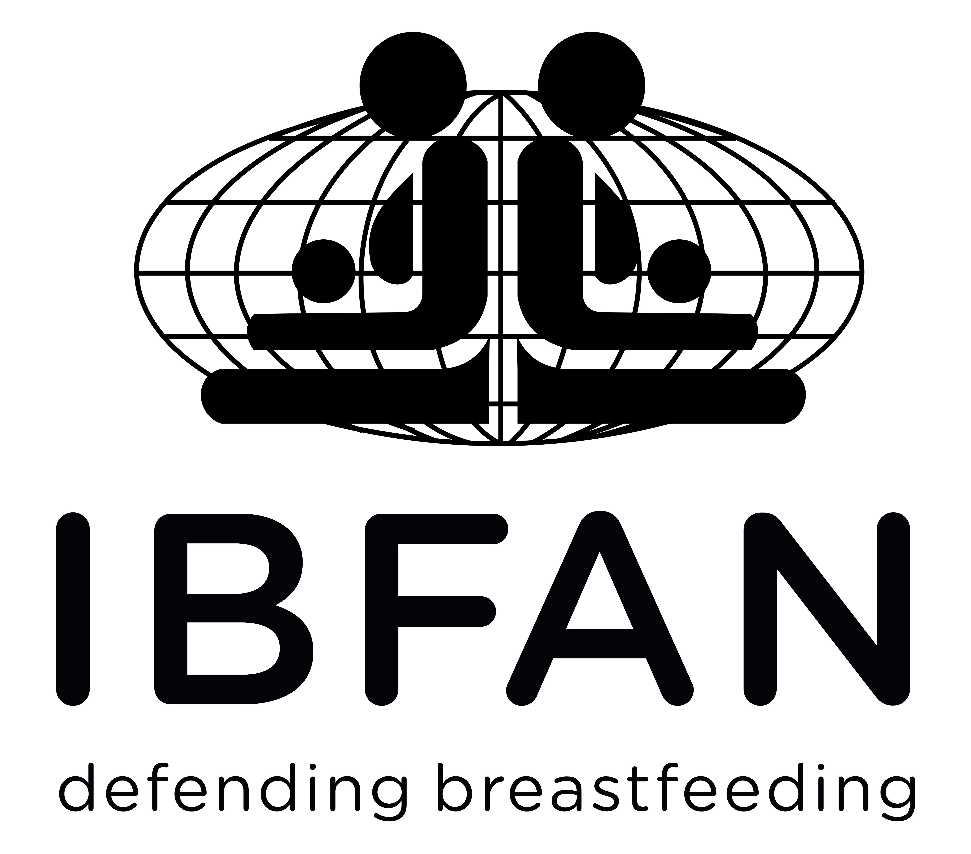

**YOUR LOGO**

Assessment Report



**Assessment Report**

**Name of the Country**

**Year:**

**PHOTO**

|  |  |
| --- | --- |
| **lgog high resolution.jpgbpni logo.jpg**  **WBT*i* Global Secretariat**  **Breastfeeding Promotion Network of India (BPNI)**  BP-33, Pitampura, Delhi-110034, India  Phone: 91-11-42683059  E-mail: [wbtigs@gmail.com](mailto:wbtigs@gmail.com)  Website: [www.worldbreastfeedingtrends.org](http://www.worldbreastfeedingtrends.org) | **YOUR logo**  **Contact detail** |

**Introduction**

*(please insert text about the report)*

**The World Breastfeeding Trends Initiative (WBTi)**

**About WBT*i***

The Breastfeeding Promotion Network of India (BPNI)/International Baby Food Action Network (IBFAN) South Asia and the World Breastfeeding Trends Initiative (WBTi) Global Secretariat launched the innovative tool in 2004 at a South Asia Partners Forum.

The WBTi assists countries to assess the status and benchmark the progress in implementation of the *Global Strategy for Infant and Young Child Feeding* in a standard way. It is based on the WHO's “Infant and Young Child Feeding: A tool for assessing national practices, policies and programmes". The WBTi programme calls on countries to conduct their assessment to measure strengths and weaknesses on the ten parameters of policy and programmes that protect, promote and support optimal infant and young child feeding (IYCF) practices. It maintains a Global Data Repository of these policies and programmes in the form of scores, color codes, report and report card for each country The WBTi assessment process brings people together and encourages collaboration, networking and local action. Organisations such as government departments, UN, health professionals, academics and other civil society partners (without Conflicts of Interest) participate in the assessment process by forming a core group with an objective to build consensus. With every assessment countries identify gaps and provide recommendations to their policy makers for affirmative action and change. The WBTi Global Secretariat encourages countries to conduct a re- assessment every 3-5 years for tracking trends in IYCF policies and programme.

**Vision & Mission**

The WBTi envisages that all countries create an enabling environment for women to be successful in breastfeeding their babies optimally at home, health facilities or at work places. The WBTi aspires to be a trusted leader to motivate policy makers and programme managers in countries, to use the global data repository of information on breastfeeding and IYCF policies and programmes. WBTi envisions serving as a knowledge platform for programme managers, researchers, policy makers and breastfeeding advocates across the globe. WBTi's mission is to reach all countries to facilitate assessment and tracking of IYCF policies and programmes through mobilising local partnerships without conflicts of interest and building a data repository for advocacy.

**Ethical Policy**

The WBTi works on 7 principles of IBFAN and does not seek or accept funds donation, grants or sponsorship from manufacturers or distributors and the front organisations of breastmilk substitutes, complementary foods, infant and young child feeding related products like breast pumps, or any such organization that has conflicts of interest.

The WBTi has identified 15 indicators in two parts, each indicator having specific significance.

|  |  |
| --- | --- |
| **Part-I deals with policy and programmes (indicator 1-10)** | **Part –II deals with infant feeding practices (indicator 11-15)** |
| 1. National Policy, Governance and Funding 2. Baby Friendly Hospital Initiative / Ten Steps to Successful Breastfeeding 3. Implementation of the International Code of Marketing of Breastmilk Substitutes 4. Maternity Protection 5. Health and Nutrition Care Systems (in support of breastfeeding & IYCF) 6. Counselling services for the pregnant and breastfeeding mothers 7. Accurate and Unbiased Information Support 8. Infant Feeding and HIV 9. Infant and Young Child Feeding during Emergencies 10. Monitoring and Evaluation | 1. Timely Initiation of Breastfeeding within one hour of birth 2. Exclusive Breastfeeding for the first six months 3. Median duration of Breastfeeding 4. Bottle-Feeding 5. Complementary Feeding-Introduction of solid, semi-solid or soft foods |

## Each indicator used for assessment has following components;

* The key question that needs to be investigated.
* Background on why the practice, policy or programme component is important.
* A list of key criteria for assessment as subset of questions to be considered in identifying strengths and weaknesses to document gaps.
* Annexes for related information

**Part I: Policies and Programmes:** The criteria of assessment has been developed for each of the ten indicators, based on the *Global Strategy for Infant and Young Child Feeding* (2002) and the Innocenti Declaration on Infant and Young Child Feeding (2005) as well as updated with most recent developments in this field. For each indicator, there is a subset of questions. Answers to these can lead to identification of the gaps in policies and programmes required to implement the *Global Strategy*. Assessment can reveal how a country is performing in a particular area of action on Breastfeeding /Infant and Young Child Feeding. Additional information is also sought in these indicators, which is mostly qualitative. Such information is used in the elaborate report, however, is not taken into account for scoring or colour coding.

**Part II: Infant and Young Child Feeding Practices** in Part II ask for specific numerical data on each practice based on data from random national household surveys. These five indicators are based on the WHO’s tool for keeping it uniform. However, additional information on some other practice indicators such as ‘continued breastfeeding’ and ‘adequacy of complementary feeding’ is also sought.

**Scoring and Colour-Coding**

*Policy and Programmes Indicator 1-10*

Once the information on the 'WBTi Questionnaire ‘is gathered and analysed, it is then entered into the web-tool. The tool provides *scoring* of each individual sub set of questions as per their weight age in the indicators 1-10 (policies and programmes). Each indicator has a maximum score of 10. Total score of ten indicators has a maximum score of 100.

The web tool also assigns *Colour-Coding* (Red/Yellow/Blue/Green) of each indicator as per the *WBTi Guidelines for* *Colour-Coding* based on the scores achieved.

**In the part II (IYCF practices)**

Indicators of part II are expressed as percentages or absolute number. Once the data is entered, the tool assigns *Colour coding* as per the *Guidelines*.

The WBTi Tool provides details of each indicator in sub-set of questions, and weight age of each.

Global acceptance of the WBT*i*

The WBTi met with success South Asia during 2004-2008 and based on this, the WBTi was introduced to other regions. By now more than 100 countries have been trained in the use of WBTi tools and 97 have completed and reported. Many of them repeated assessments during these years.

WBTi has been published as BMJ published news in the year 2011, when 33 country WBTi report was launched[1]. Two peer reviewed publications in the international journals add value to the impact of WBTi, in Health Policy and Planning in 2012 when 40 countries had completed[2], and in the Journal of Public Health Policy in 2019[3] when 84 countries completed it.

The WBTi has been accepted globally as a credible source of information on IYCF polices and programmes and has been cited in global guidelines and other policy documents e.g. WHO National Implementation of BFHI 2017[4] and IFE Core group’s Operational Guidance on Infant Feeding in Emergencies, 2017[5].

Accomplishment of the WBTi assessment is one of the seven policy asks in the Global Breastfeeding Collective (GBC), a joint initiative by UNICEF & WHO to accelerate progress towards achieving the WHA target of exclusive breastfeeding to 50% by 2030. The Global Breastfeeding Scorecard for tracking progress for breastfeeding policies and programmes developed by the Collective has identified a target that at least three-quarters of the countries of the world should be able to conduct a WBTi assessment every five years by 2030.[6] The report on implementation of the International Code of Marketing for Breastmilk Substitutes also used WBTi as a source. The Global database on the Implementation of Nutrition Action (GINA) of WHO has used WBTi as a source.[7] Global researchers have used WBTi findings to predict possible increase in exclusive breastfeeding with increasing scores and found it valid for measuring inputs into global strategy.[8] Other than this PhD students have used WBTi for their research work, and New Zealand used WBTi for developing their National Strategic Plan of Action on breastfeeding 2008-2012.

The WBT*i* Guidelines for Colour-Coding (Part I and II)

|  |  |  |  |  |
| --- | --- | --- | --- | --- |
| **Table 1:** WBT*i* Guidelines for Colour-Coding  for Individual indicators1-10 | |  | **Table 2:** WBT*i* Guidelines for Colour-Coding  1-10 indicators **(**policy and programmes) | |
| ***Scores*** | ***Colour-coding*** |  | ***Scores*** | ***Colour-coding*** |
| 0 – 3.5 | **Red** |  | 0 – 30.9 | **Red** |
| 4 – 6.5 | **Yellow** |  | 31 – 60.9 | **Yellow** |
| 7 – 9 | **Blue** |  | 61 – 90.9 | **Blue** |
| > 9 | **Green** |  | 91 – 100 | **Green** |

**Table 3:** WBT*i* Guidelines for Colour-Coding Individual indicators 11-15 (Practices)

|  |  |  |  |  |
| --- | --- | --- | --- | --- |
| *WBTi Guidelines for Indicator 11 (Initiation of breastfeeding {within 1 hour})* | |  | *WBTi Guidelines for Indicator 12 (Exclusive Breastfeeding {for first 6 months})* | |
| ***Percentage (WHO’s key)*** | ***Colour-coding*** |  | ***Percentage (WHO’s key)*** | ***Colour-coding*** |
| 0.1-29% | **Red** |  | 0.1-11% | **Red** |
| 29.1-49% | **Yellow** |  | 11.1-49% | **Yellow** |
| 49.1%-89% | **Blue** |  | 49.1-89% | **Blue** |
| 89.1-100% | **Green** |  | 89.1-100% | **Green** |

|  |  |  |  |  |
| --- | --- | --- | --- | --- |
| *WBTi Guidelines for Indicator 13 (Median Duration of Breastfeeding)* | |  | *WBTi Guidelines for Indicator 14 (Bottle-feeding {0-12 months})* | |
| ***Months (WHO’s key)*** | ***Colour-coding*** |  | ***Percentage (WHO’s key)*** | ***Colour-coding*** |
| 0.1-18 months | **Red** |  | 29.1-100% | **Red** |
| 18.1-20 months | **Yellow** |  | 4.1-29% | **Yellow** |
| 20.1-22 months | **Blue** |  | 2.1-4% | **Blue** |
| 22.1-24 months | **Green** |  | 0.1-2% | **Green** |

|  |  |
| --- | --- |
| *WBTi Guidelines for Indicator 15 (Complementary Feeding {6-8 months})* | |
| ***Percentage (WHO’s key)*** | ***Colour-coding*** |
| 0.1-59% | **Red** |
| 59.1-79% | **Yellow** |
| 79.1%-94% | **Blue** |
| 94.1-100% | **Green** |

**Background**

*(please insert general information about the country regarding child nutrition, child survival, any initiation to improve IYCF practices etc. )*

**Assessment process followed by the country**

**List of partners for the assessment process**

**Assessment Findings**

Part I: IYCF Policies and Programmes

In Part I, each question has possible score of 0-3 and each indicator has a maximum score of 10. Once information about the indicators is entered, the achievement on the particular target indicator is then rated i.e. Red, Yellow, Blue and Green based on the guidelines.

**Indicator 1: National Policy, Governance and Funding**

|  |
| --- |
| **Key question/s:** Is there a national breastfeeding/ infant and young child feeding policy that protects, promotes and supports optimal breastfeeding and infant and young child feeding (IYCF) practices? Is the policy supported by a government programme? Is there a plan to implement this policy? Is sufficient funding provided? Is there a mechanism to coordinate like e.g. National breastfeeding committee and a coordinator for the committee? (See Annex 1) |

|  |  |  |
| --- | --- | --- |
| **Criteria for Assessment –Policy and Funding** | ***✓ Check all that apply*** | |
| 1.1) A national breastfeeding/infant and young child feeding policy/guideline (stand alone or integrated) has been officially approved by the government | ❑Yes = 1 | ❑No=0 |
| 1.2) The policy recommends initiation of breastfeeding within one hour of birth and exclusive breastfeeding for the first six months, complementary feeding to be started after six months and continued  breastfeeding up to 2 years and beyond. | ❑Yes = 1 | ❑No=0 |
| 1.3) A national plan of action is approved with goals, objectives,  indicators and timelines (stand alone or integrated) | ❑Yes = 2 | ❑No = 0 |
| 1.4) The country (government and others) is spending on breastfeeding and IYCF interventions[9]  a. no funding  b. < $1 per birth  c. $1-2 per birth  d. $2-5 per birth  e. =or >$5 per birth | √ Check one which is applicable  ❑ 0  ❑ 0.5  ❑ 1  ❑ 1.5  ❑ 2.0 | |
| **Governance** |  |  |
| 1.5) There is a National Breastfeeding/IYCF Committee | ❑Yes =1 | ❑No = 0 |
| 1.6) The committee meets, monitors and reviews the plans and  progress made on a regular basis | ❑Yes = 2 | ❑No = 0 |
| 1.7) The committee links effectively with all other sectors like finance, health, nutrition, information, labor, disaster management,  agriculture, social services etc. | ❑Yes = 0.5 | ❑No = 0 |
| 1.8) The committee is headed by a coordinator with clear terms of reference, regularly coordinating action at national and sub national  level and communicating the policy and plans. | ❑Yes = 0.5 | ❑No = 0 |
| **Total Score** | **____/10** | |

Additional useful information

1. What is the amount of money currently being spent annually on the breastfeeding and IYCF interventions?
2. How many babies are born each year?
3. Is the food industry/representative a part of the breastfeeding/IYCF committee?

Information Sources Used *(please provide web-links or references for each of the information used above in answering the questions. To be acceptable, there has to be a source for each.*

1. *_____________________*
2. *_____________________*
3. *_____________________*
4. *_____________________*

**Conclusions** *(Summarize which aspects ofIndicator-1 i.e. IYCF policy, plan and funding are appropriate; which need improvement and why; and any further analysis needed)****:***

**Gaps** *(List gaps identified in the implementation of this indicator)***:**

1. *_____________________*
2. *_____________________*
3. *_____________________*
4. *_____________________*

**Recommendations** *(List actions recommended to bridge the gaps):*

1. *_____________________*
2. *_____________________*
3. *_____________________*
4. *_____________________*

**Indicator 2: Baby Friendly Hospital Initiative / Ten Steps to Successful Breastfeeding**

|  |
| --- |
| **Key questions**  What percentage of hospitals/maternity facilities are designated/ accredited/awarded OR what % of new mothers have received maternity care as per the 'Ten Steps' within the past 5 years? What is the quality of implementation of BFHI? (see annex 2.1,2.2,2.3,2.4,2.5,2.6,2.7) |

**Quantitative Criteria for assessment**

|  |
| --- |
| 2.1)______ out of ____total hospitals (both public &private) offering maternity services that have been designated/accredited/awarded/measured for implementing 10 steps within the past 5 years. |

|  |  |
| --- | --- |
| Criteria for assessment | **✓ Check one which is applicable** |
| 0 | **❑ 0** |
| 0.1 – 20% | **❑** 1 |
| 20.1 – 49% | **❑** 2 |
| 49.1 – 69% | **❑** 3 |
| 69.1-89 % | **❑** 4 |
| 89.1 – 100% | **❑** 5 |
| **Total score 2.1** | **_____/5** |

Qualitative Criteria for assessment

| Criteria for assessment | **✓ Check that apply** | |
| --- | --- | --- |
| 2.2) There is a national coordination body/mechanism for BFHI / to implement Ten Steps with a clearly identified focal person. | ❑ Yes = 1 | ❑ No=0 |
| 2.3) The Ten Steps have been integrated into national/ regional/hospital policy and standards for all involved health professionals. | ❑ Yes = 0.5 | ❑ No=0 |
| 2.4) An external assessment mechanism is used for accreditation /designation/awarding/evaluate the health facility. | ❑ Yes = 0.5 | ❑ No=0 |
| 2.5) Provision for the reassessment[10] have been incorporated in national plans to implement Ten Steps. | ❑ Yes = 0.5 | ❑ No=0 |
| 2.6) The accreditation/designation/awarding/measuring process for BFHI/implementing the Ten Steps includes assessment of knowledge and competence of the nursing and medical staff. | ❑ Yes = 1 | ❑ No=0 |
| 2.7) The external assessment process relies on interviews of mothers. | ❑ Yes = 0.5 | ❑ No=0 |
| 2.8) The International Code of Marketing of Breastmilk Substitutes is an integral part of external assessment. | ❑ Yes = 0.5 | ❑ No=0 |
| 2.9) Training on the Ten Steps and standard of care are included in the pre-service curriculum for nurses, midwives and doctors and other involved health care professionals. | ❑ Yes = 0.5 | ❑ No=0 |
| **Total Score (2.2 to 2.9)** | **____/5** | |

|  |  |
| --- | --- |
| **Total Score (2.1 to 2.9)** | **_______/10** |

**Additional information:** Can you explain the process in the country and how it is aligned to the earlier or revised ten Steps and if it relies on national or international criteria (see Appendix: indicators for monitoring.

Please describe the deviations from the international criteria.

Information Sources Used *(please provide web-links or references for each of the information used above in answering the questions. To be acceptable, there has to be a source for each.*

1. *_____________________*
2. *_____________________*
3. *_____________________*
4. *_____________________*

**Conclusions** *(Summarize how the country is doing in achieving Baby Friendly Hospital Initiative targets (implementing ten steps to successful breastfeeding) in quantity and quality both. List any aspects of the initiative needing improvement and why and any further analysis needed):*

**Gaps** *(List gaps identified in the implementation of this indicator)***:**

1. *_____________________*
2. *_____________________*
3. *_____________________*
4. *_____________________*

**Recommendations** *(List action recommended to bridge the gaps):*

1. *_____________________*
2. *_____________________*
3. *_____________________*
4. *_____________________*

**Indicator 3: Implementation of the International Code of Marketing of Breastmilk Substitutes**

|  |
| --- |
| **Key questions:** Are the International Code of Marketing of Breastmilk Substitutes and subsequent WHA resolutions in effect and implemented in the country? Has any action been taken to monitor and enforce the above? (See Annex 3.1, 3.2) |

|  |  |
| --- | --- |
| **Criteria for Assessment (***Legal Measures that are in Place in the Country***)** | |
|  | **Score** |
| **3a: Status of the International Code of Marketing**  *✓ Check that applies upto the questions 3.9. If it is more than one, tick the higher one.* | |
| 3.1 No action taken | ❑0 |
| 3.2 The best approach is being considered | ❑0.5 |
| 3.3 Draft measure awaiting approval (for not more than three years) | ❑1 |
| 3.4 Few Code provisions as voluntary measure | ❑1.5 |
| 3.5 All Code provisions as a voluntary measure | ❑2 |
| 3.6 Administrative directive/circular implementing the code in full or in part in health facilities with administrative sanctions | ❑3 |
| 3.7 Some articles of the Code as law | ❑4 |
| 3.8 All articles of the Code as law | ❑5 |
| 3.9 Relevant provisions of World Health Assembly (WHA) resolutions subsequent to the Code are included in the national legislation[11]   1. Provisions based on 1 to3 of the WHA resolutions as listed below are included 2. Provisions based on more than 3 of the WHA resolutions as listed below are included | ❑5.5  ❑6 |
| **Total score 3a** |  |

|  |  |
| --- | --- |
| **3b: Implementation of the Code/National legislation**  *Check that applies. It adds up to the 3a scores.* | |
| 3.10 The measure/law provides for a monitoring system independent from the industry | ❑1 |
| 3.11 The measure provides for penalties and fines to be imposed to violators | ❑1 |
| 3.12 The compliance with the measure is monitored and violations reported to concerned agencies | ❑1 |
| 3.13 Violators of the law have been sanctioned during the last three years | ❑1 |
| **Total Score 3b** |  |

|  |  |
| --- | --- |
| **Total Score (3a + 3b)** | **__/10** |

Additional Information

1. How often you see the violations of the Code or National law?(Attach some examples)
2. Has your country taken any steps that strengthen the Code implementation?
3. How is the Code information disseminated among the health workers? (List some examples)

*Information Sources Used (please provide web-links or references for each of the information used above in answering the questions. To be acceptable, there has to be a source for each.*

1. *_____________________*
2. *_____________________*
3. *_____________________*
4. *_____________________*

**Conclusions** *(Summarize which aspects of Code implementation have been achieved, and which aspects need improvement and why. Identify areas needing further analysis)*

**Gaps** *(List gaps identified in the implementation of this indicator)***:**

1. *_____________________*
2. *_____________________*
3. *_____________________*
4. *_____________________*

**Recommendations** *(List action recommended to bridge the gaps):*

1. *_____________________*
2. *_____________________*
3. *_____________________*
4. *_____________________*

**Indicator 4: Maternity Protection**

|  |
| --- |
| **Key question:** Is there a legislation and are there other measures (policies, regulations, practices) that meet or go beyond the International Labor Organization (ILO) standards for protecting and supporting breastfeeding for mothers, including mothers working in the informal sector? (See Annex 4) |

| Criteria for Assessment | Scores |
| --- | --- |
| 4.1) Women covered by the national legislation are protected with the following weeks of paid maternity leave:   1. Any leave less than 14 weeks 2. 14 to 17weeks 3. 18 to 25 weeks 4. 26 weeks or more | *✓ Tick one which is applicable*  ❑0.5  ❑1  ❑1.5  ❑2 |
| 4.2) Does the national legislation provide at least one breastfeeding break or reduction of work hours?   * 1. Unpaid break   2. Paid break   3. No break | *✓ Tick one which is applicable*  ❑0.5  ❑1  ❑0 |
| 4.3) The national legislation obliges private sector employers to   1. Give at least 14 weeks paid maternity leave 2. Paid nursing breaks. | *✓ Tick one or both*  ❑YES (0.5)❑NO (0)  ❑ YES (0.5) ❑ NO (0) |
| 4.4) There is provision in national legislation that provides for work site accommodation for breastfeeding and/or childcare in work places in the formal sector.   1. Space for Breastfeeding/Breastmilk expression 2. Crèche | *✓ Tick one or both*  ❑ YES (1) ❑ NO (0)  ❑ YES (0.5) ❑ NO (0) |
| 4.5) Women in informal/unorganized and agriculture sector are:   1. Accorded some protective measures 2. Accorded the same protection as women working in the formal sector 3. No measures | *✓ Tick one which is applicable*  ❑0.5  ❑1  ❑0 |
| 4.6)   1. Accurate and complete information about maternity protection laws, regulations or policies is made available to workers by their employers on commencement. 2. There is a system for monitoring compliance and a way for workers to complain if their entitlements are not provided. | *✓ Tick one or both*  ❑ YES (0.5) ❑ NO (0)  ❑ YES (0.5) ❑ NO (0) |
| 4.7) Paternity leave is granted in public sector for at least 3 days. | *✓ Tick one which is applicable*  ❑YES (0.5)  ❑NO (0) |
| 4.8) Paternity leave is granted in the private sector for at least 3 days. | *✓ Tick one which is applicable*  ❑YES (0.5)  ❑NO (0) |
| 4.9) There is legislation providing health protection for pregnant and breastfeeding workers: they are informed about hazardous conditions in the workplace and provided alternative work at the same wage until they are no longer pregnant or breastfeeding. | *✓ Tick one which is applicable*  ❑YES (0.5)  ❑NO (0) |
| 4.10) There is legislation prohibiting employment discrimination and assuring job protection for women workers during breastfeeding period. | *✓ Tick one which is applicable*  ❑YES (1)  ❑NO (0) |
| **Total Score** | **____/10** |

Any additional information

1. Please provide information on the current situation regarding paternity leave and its relation to maternity leave.
2. Does the financial allocation for paternity leave affect the maternity leave?
3. How best maternity leave is positioned in the context of optimal breastfeeding protection?

Information Sources Used *(please provide web-links or references for each of the information used above in answering the questions. To be acceptable, there has to be a source for each.*

1. *_____________________*
2. *_____________________*
3. *_____________________*
4. *_____________________*

**Conclusions** *(Summarize which aspects of the legislation are appropriate, and which aspects need improvement and why. Identify areas needing further analysis)***:**

**Gaps** *(List gaps identified in the implementation of this indicator)***:**

1. *_____________________*
2. *_____________________*
3. *_____________________*
4. *_____________________*

**Recommendations** *(List action recommended to bridge the gaps):*

1. *_____________________*
2. *_____________________*
3. *_____________________*
4. *_____________________*

**Indicator 5: Health and Nutrition Care Systems (in support of breastfeeding & IYCF)**

|  |
| --- |
| **Key question:** Do care providers in the health and nutrition care systems undergo training in knowledge and skills, and do their pre-service education curricula support optimal infant and young child feeding; do these services support mother-friendly and breastfeeding-friendly birth practices, do the policies of health care services support mothers and children, and are health workers trained on their responsibilities under the Code? (See Annex 5.1, 5.2) |

| *Criteria for assessment* | *✓ Check* ***one*** *that applies in each question* | | |
| --- | --- | --- | --- |
| 5.1) A review of health provider schools and pre-service education programmes for healthcare professionals,[12] indicates that IYCF curricula or session plans are adequate/ inadequate  (See Annex 5.1) | > 20 out of 25 content/skills are included  ❑ 2 | 5-20 out of 25 content/ skills are included  ❑ 1 | Fewer than 5 content/skills are included  ❑ 0 |
| 5.2) Standards and guidelines for mother- friendly childbirth procedures and support have been disseminated to all facilities and personnel providing maternity care. (See Annex 5.2) | Disseminate to> 50% facilities  ❑ 2 | Disseminate to 20-50% facilities  ❑ 1 | No guideline, or disseminated to < 20% facilities  ❑ 0 |
| 5.3) There are in-service training programmes available providing knowledge and skills related to IYCF for relevant health/nutrition care providers.[13] | Available for all relevant workers  ❑ 2 | Limited Availability  ❑ 1 | Not available  ❑0 |
| 5.4) Health workers are trained on their responsibilities under the Code and national regulations, throughout the country. | Throughout the country  ❑1 | Partial Coverage  ❑ 0.5 | Not trained  ❑ 0 |
| 5.5) Infant and young child feeding information and skills are integrated, as appropriate, into training programmes not covered in 5.1 but where the care providers may have some contact with families with infants and young children.(Training programmes such as diarrhea control, HIV, NCDs, Women’s Health etc.) | Integrated in > 2 training programmes  ❑ 1 | 1-2 training programmes  ❑ 0.5 | Not integrated  ❑ 0 |
| 5.6) In-service training programmes referenced in 5.5 are being provided throughout the country.[14] | Throughout the country  ❑ 1 | Partial Coverage  ❑ 0.5 | Not provided  ❑ 0 |
| 5.7) Health policies provide for mothers and babies to stay together when one of them is hospitalised. | Provision for staying together for both  ❑ 1 | Provision for only to one of them: mothers or babies  ❑ 0.5 | No provision  ❑ 0 |
| **Total Score** | **______/10** | | |

Information Sources Used *(please provide web-links or references for each of the information used above in answering the questions. To be acceptable, there has to be a source for each).*

1. *_____________________*
2. *_____________________*
3. *_____________________*
4. *_____________________*

**Conclusions: (**Summarize which aspects of health and nutrition care system are appropriate and which need improvement and why. Identify areas needing further analysis.)

**Gaps:** *(List gaps identified in the implementation of this indicator)*

1. *_____________________*
2. *_____________________*
3. *_____________________*
4. *_____________________*

**Recommendations:** *(List action recommended to bridge the gaps):*

1. *_____________________*
2. *_____________________*
3. *_____________________*
4. *_____________________*

**Indicator 6: Counselling Services for the Pregnant and Breastfeeding Mothers**

|  |
| --- |
| **Key question:** Are there counselling services in place to protect, promote and support breastfeeding and optimal infant and young child feeding practices both at facility and community level (See Annex 6.1) |

|  |  |  |  |
| --- | --- | --- | --- |
| **Criteria of assessment** | *✓ Check* ***ONE*** *that applies in each question* | | |
| 6.1) Pregnant women receive counselling services for breastfeeding during ANC. | >90%  ❑ 2 | 50-89%  ❑ 1 | <50%  ❑ 0 |
| 6.2) Women receive counselling and support for initiation breastfeeding and skin to contact within an hour birth. | >90%  ❑ 2 | 50-89%  ❑ 1 | <50%  ❑ 0 |
| 6.3) Women receive post-natal counselling for exclusive breastfeeding at hospital or home. | >90%  ❑ 2 | 50-89%  ❑ 1 | <50%  ❑ 0 |
| 6.4) Women/families receive breastfeeding and infant and young child feeding counselling at community level. | >90%  ❑ 2 | 50-89%  ❑ 1 | <50%  ❑ 0 |
| 6.5) Community-based health workers are trained in counselling skills for infant and young child feeding. | >50%  ❑ 2 | <50%  ❑ 1 | No Training  ❑ 0 |
| **Total Score:** | **_____/10** | | |

Additional Information: *If pre-lacteal feeding is going on, please give examples, share some challenges to providing counselling at community level.*

*Information Sources Used (please provide web-links or references for each of the information used above in answering the questions. To be acceptable, there has to be a source for each.*

1. *_____________________*
2. *_____________________*
3. *_____________________*
4. *_____________________*

**Conclusions** *(Summarize which aspects of a health and nutrition care system are adequate and which need improvement and why. Identify areas needing further analysis)****:***

**Gaps** *(List gaps identified in the implementation of this indicator)***:**

1. *_____________________*
2. *_____________________*
3. *_____________________*
4. *_____________________*

**Recommendations** *(List action recommended to bridge the gaps):*

1. *_____________________*
2. *_____________________*
3. *_____________________*
4. *_____________________*

**Indicator 7: Accurate and Unbiased Information Support**

|  |
| --- |
| **Key question:** Are comprehensive Information, Education and Communication (IEC) strategies for improving infant and young child feeding (breastfeeding and complementary feeding) being implemented?(See: Annex 7.1, 7.2, 7.3) |

|  |  |  |
| --- | --- | --- |
| Criteria for assessment | *✓ Check that apply* | |
| 7.1) There is a national IEC strategy for improving infant and young child feeding. | YES  ❑ 2 | NO  ❑ 0 |
| 7.2) Messages are communicated to people through different channels and in local context. | YES  ❑ 1 | No  ❑ 0 |
| 7.3) IEC strategy, programmes and campaigns like WBW and are free from commercial influence. | YES  ❑ 1 | No  ❑ 0 |
| 7.4) Breastfeeding/IYCF IEC materials and messages are objective, consistent and in line with national and/or international recommendations. | YES  ❑ 2 | No  ❑ 0 |
| 7.5) IEC programmes (eg World Breastfeeding Week) that include infant and young child feeding are being implemented at national and local level. | YES  ❑ 2 | No  ❑ 0 |
| 7.6) IEC materials/messages include information on the risks of artificial feeding in line with WHO/FAO Guidelines on preparation and handling of powdered infant formula (PIF).[15] | YES  ❑ 2 | No  ❑ 0 |
| **Total Score:** | **_____/10** | |

*Information Sources Used (please provide web-links or references for each of the information used above in answering the questions. To be acceptable, there has to be a source for each.*

1. *_____________________*
2. *_____________________*
3. *_____________________*

**Conclusions** *(Summarize which aspects of the IEC programme are appropriate and which need improvement and why. Identify areas needing further analysis)****:***

**Gaps** *(List gaps identified in the implementation of this indicator)***:**

1. *_____________________*
2. *_____________________*
3. *_____________________*
4. *_____________________*

**Recommendations** *(List action recommended to bridge the gaps):*

1. *_____________________*
2. *_____________________*
3. *_____________________*
4. *_____________________*

**Indicator 8: Infant Feeding and HIV**

|  |
| --- |
| **Key question:** Are policies and programmes in place to ensure that mothers living with HIV are supported to carry out the global/national recommended Infant feeding practice? |

|  |  |  |
| --- | --- | --- |
| *Criteria for Assessment*[16] | *✓ Check that apply* | |
| 8.1) The country has an updated policy on Infant feeding and HIV, which is in line with the international guidelines  on infant and young child feeding and HIV[17]. | YES  ❑ 2 | NO  ❑ 0 |
| 8.2) The infant feeding and HIV policy gives effect to the International Code/ National Legislation. | YES  ❑ 1 | NO  ❑ 0 |
| 8.3) Health staff and community workers of HIV programme have received training on HIV and infant feeding counselling in past 5 years. | YES  ❑ 1 | NO  ❑ 0 |
| 8.4) HIV Testing and Counselling (HTC)/ Provider- Initiated HIV Testing and Counselling (PIHTC)/ Voluntary and Confidential Counselling and Testing (VCCT) is available and offered routinely to couples who are considering pregnancy and to pregnant women and  their partners. | YES  ❑ 1 | NO  ❑ 0 |
| 8.5) The breastfeeding mothers living with HIV are  provided ARVs in line with the national recommendations. | YES  ❑ 1 | NO  ❑ 0 |
| 8.6) Infant feeding counselling is provided to all mothers  living with HIV appropriate to national circumstances. | YES  ❑ 1 | NO  ❑ 0 |
| 8.7) Mothers are supported and followed up in carrying out  the recommended national infant feeding | YES  ❑ 1 | NO  ❑ 0 |
| 8.8) Country is making efforts to counter misinformation on HIV and infant feeding and to promote, protect and support 6 months of exclusive breastfeeding and continued  breastfeeding in the general population. | YES  ❑ 1 | NO  ❑ 0 |
| 8.9) Research on Infant feeding and HIV is carried out to determine the effects of interventions to prevent HIV transmission through breastfeeding on infant feeding practices and overall health outcomes for mothers and infants, including those who are HIV negative or of  unknown status. | YES  ❑ 1 | NO  ❑ 0 |
| **Total Score:** | **____/10** | |

*Information Sources Used (please provide web-links or references for each of the information used above in answering the questions. To be acceptable, there has to be a source for each.*

1. *_____________________*
2. *_____________________*
3. *_____________________*
4. *_____________________*

**Conclusions** *(Summarize which aspects of HIV and infant feeding programming are appropriate, and which aspects need improvement and why. Identify areas needing further analysis)****:***

**Gaps** *(List gaps identified in the implementation of this indicator)***:**

1. *_____________________*
2. *_____________________*
3. *_____________________*
4. *_____________________*

**Recommendations** *(List action recommended to bridge the gaps):*

1. *_____________________*
2. *_____________________*
3. *_____________________*
4. *_____________________*

**Indicator 9: Infant and Young Child Feeding during Emergencies**

|  |
| --- |
| **Key question:** Are appropriate policies and programmes in place to ensure that mothers, infants and young children will be provided adequate protection and support for appropriate feeding during emergencies? (See Annex 9) |

| **Criteria for assessment** | **✓ Check that apply** | |
| --- | --- | --- |
| 9.1) The country has a comprehensive Policy/Strategy/ Guidance on infant and young child feeding during emergencies as per the global recommendations with measurable indicators. | YES  ❑ 2 | NO  ❑ 0 |
| 9.2) Person(s) tasked to coordinate and implement the above policy/ strategy/guidance have been appointed at the national and sub national levels | YES  ❑ 2 | NO  ❑ 0 |
| 9.3) The health and nutrition emergency preparedness and response (stand alone or integrated) recommendation includes: |  |  |
| 1. Basic and technical interventions to create an enabling environment for breastfeeding, including counselling by appropriately skill trained counsellors, and support for relactation and wet-nursing. | YES  ❑ 0.5 | NO  ❑ 0 |
| 1. Measures to protect, promote and support appropriate and complementary feeding practices | YES  ❑ 0.5 | NO  ❑ 0 |
| 1. Measures to protect and support the non breast-fed infants | YES  ❑ 0.5 | NO  ❑ 0 |
| 1. Space for IYCF counselling support services. | YES  ❑ 0.5 | NO  ❑ 0 |
| 1. Measures to minimize the risks of artificial feeding, including an endorsed Joint statement on avoidance of donations of breastmilk substitutes, bottles and teats, and standard procedures for handling unsolicited donations, and minimize the risk of formula feeding, procurement management and use of any infant formula and BMS, in accordance with the global recommendations on emergencies | YES  ❑ 0.5 | NO  ❑ 0 |
| 1. Indicators, and recording and reporting tools exist to closely monitor and evaluate the emergency response in the context of feeding of infants and young children. | YES  ❑ 0.5 | NO  ❑ 0 |
| 9.4) Adequate financial and human resources have been allocated for implementation of the emergency preparedness and response plan on IYCF | YES  ❑2 | NO  ❑0 |
| 9.5) Appropriate orientation and training material on infant and young child feeding in emergencies has been integrated into pre-service and in- service training for emergency management and relevant health care personnel. | YES  ❑0.5 | NO  ❑0 |
| 9.6) Orientation and training is taking place as per the national plan on emergency preparedness and response is aligned with the global recommendations (at the national and sub-national levels) | Yes  ❑ 0.5 | NO  ❑ 0 |
| **Total Score:** | **_____/10** | |

Additional Information: Please share any stories of implementing the IFE in your country during a disaster

*Information Sources Used (please provide web-links or references for each of the information used above in answering the questions. To be acceptable, there has to be a source for each.*

1. *_____________________*
2. *_____________________*
3. *_____________________*
4. *_____________________*

**Conclusions** *(Summarize which aspects of emergency preparedness and response are appropriate and which need improvement and why. Identify areas needing further analysis)****:***

**Gaps** *(List gaps identified in the implementation of this indicator)***:**

1. *_____________________*
2. *_____________________*
3. *_____________________*
4. *_____________________*

**Recommendations** *(List actions recommended to bridge the gaps):*

1. *_____________________*
2. *_____________________*
3. *_____________________*
4. *_____________________*

**Indicator 10: Monitoring and Evaluation**

|  |
| --- |
| **Key question:** Are monitoring and evaluation systems in place that routinely or periodically collect, analyse and use data to improve infant and young child feeding practices? |

|  |  |  |
| --- | --- | --- |
| **Criteria for assessment** | ✓ Check that apply | |
| 10.1) Monitoring and evaluation of the IYCF programmes or activities (national and sub national levels) include IYCF indicators (early breastfeeding within an hour, exclusive breastfeeding 0-6 months, continued breastfeeding, complementary feeding and adequacy of complementary feeding) | YES  ❑ 2 | NO  ❑ 0 |
| 10.2) Data/information on progress made in implementing the IYCF programme are used by programme managers to guide  planning and investment decisions. | YES  ❑ 1 | NO  ❑ 0 |
| 10.3) Data on progress made in implementing IYCF programme  and activities are routinely or periodically collected at the sub national and national levels. | YES  ❑ 3 | NO  ❑ 0 |
| 10.4) Data/information related to IYCF programme progress are  reported to key decision-makers. | YES  ❑ 1 | NO  ❑ 0 |
| 10.5) Infant and young child feeding practices data is generated at least annually by the national health and nutrition surveillance  system, and/or health information system. | YES  ❑ 3 | NO  ❑ 0 |
| **Total Score** | **_____/10** | |

***Additional Information***

*Please share challenges being faced at national level, and solutions offered for monitoring the infant and young child feeding practices.*

*Information Sources Used (please provide web-links or references for each of the information used above in answering the questions. To be acceptable, there has to be a source for each.*

1. *_____________________*
2. *_____________________*
3. *_____________________*

**Conclusions** *(Summarize which aspects of monitoring and evaluation are appropriate and which need improvement and why. Identify areas needing further analysis)****:***

**Gaps** *(List gaps identified in the implementation of this indicator)***:**

1. *_____________________*
2. *_____________________*
3. *_____________________*
4. *_____________________*

**Recommendations** *(List actions recommended to bridge the gaps):*

1. *_____________________*
2. *_____________________*
3. *_____________________*
4. *_____________________*

**Part II – IYCF Practices**

In Part II ask for specific numerical data on each infant and young child feeding practice. Those involved in this assessment are advised to use data from a random household survey that is national in scope[18]. The data thus collected is entered into the web- based printed toolkit. The achievement on the particular target indicator is then rated i.e. **Red, Yellow, Blue and Green**. The cut off points for each of these levels of achievement were selected systematically, based on an analysis of past achievements on these indicators in developing countries. These are incorporated from the WHO’s tool.

Definition of various quantitative indicators have been taken from “WHO’s Indicators for assessing infant and young child feeding practices - 2008” Available at: <http://www.who.int/nutrition/publications/infantfeeding/9789241596664/en/> (Annex 10.1)

Preferably, data should have been collected in past five years. Most recent data should be used, which is national in scope.

**Indicator 11: Initiation of Breastfeeding (within 1 hour)**

|  |
| --- |
| **Key question:** What is the percentage of newborn babies breastfed within one hour of birth? ______% |

**Assessment**

|  |  |  |  |
| --- | --- | --- | --- |
| Indicator 11:Initiation of Breastfeeding (within 1 hour) | *Key to rating adapted from WHO tool (see Annex 11.1)* | ***Please enter your country data in %*** | ***Colour-rating*** |
| 0.1-29% |  | **Red** |
| 29.1-49% |  | **Yellow** |
| 49.1-89% |  | **Blue** |
| 89.1-100% |  | **Green** |

Data Source (including year):

Additional Information

Please provide information on use of pre-lacteal feeds, use of formula during stay in health facility, with specific challenges in cesarean section delivery, or any other relevant information you want to share in the report.

**Indicator 12: Exclusive Breastfeeding under 6 months**

|  |
| --- |
| **Key question:** What is the percentage of infants less than 6 months of age who were exclusively breastfed in the last 24 hours?_____% |

**Assessment**

|  |  |  |  |
| --- | --- | --- | --- |
| Indicator 12:Exclusive Breastfeeding under 6 months | *Key to rating adapted from WHO tool (see Annex 11.1)* | ***Please enter your country data in %*** | ***Colour-rating*** |
| 0.1-11% |  | **Red** |
| 11.1-49% |  | **Yellow** |
| 49.1-89% |  | **Blue** |
| 89.1-100% |  | **Green** |

Data Source (including year):

Additional Information

Please provide information on cultural use supplements during this period, challenges to achieve exclusivity, or any other relevant information you want to share in the report.

Indicator 13: Median Duration of Breastfeeding

|  |
| --- |
| **Key question:** Babies are breastfed for a median duration of how many months? _____Months |

**Assessment**

|  |  |  |  |
| --- | --- | --- | --- |
| Indicator 13:Median Duration of Breastfeeding | *Key to rating adapted from WHO tool (see Annex 11.1)* | ***Please enter your country data in months*** | ***Colour-rating*** |
| 0.1-18 **Months** |  | **Red** |
| 18.1-20 ’’ |  | **Yellow** |
| 20.1-22 ’’ |  | **Blue** |
| 22.1-24 or beyond ’’ |  | **Green** |

Data Source (including year):

Additional Information

If the data for this indicator is not available, please provide information on the “continued breastfeeding” at 1 and 2 years.

Indicator 14: Bottle-feeding

|  |
| --- |
| **Key question:** What percentage of breastfed babies 0-12 months of age, who are fed with any foods or drinks (even breastmilk) from bottles? _____% |

**Assessment**

|  |  |  |  |
| --- | --- | --- | --- |
| Indicator 14:Bottle-feeding (0-12 months) | *Key to rating adapted from WHO tool (see Annex 11.1)* | ***Please enter your country data in %*** | ***Colour-rating*** |
| 29.1-100% |  | **Red** |
| 4.1-29% |  | **Yellow** |
| 2.1-4% |  | **Blue** |
| 0.1-2% |  | **Green** |

Data Source (including year):

Additional Information

Please provide information if bottle feeding is on the rise and is that related to advertising etc. or any other relevant information on bottle –feeding may be useful.

Indicator 15: Complementary Feeding (6-8 months)

|  |
| --- |
| **Key question:** Percentage of breastfed babies receiving complementary foods at 6-8 months of age? ______% |

**Assessment**

|  |  |  |  |
| --- | --- | --- | --- |
| Indicator 15:Complementary Feeding (6-8 months) | *Key to rating adapted from WHO tool (see Annex 11.1)* | ***Please enter your country data in %*** | ***Colour-rating*** |
| 0.1-59% |  | **Red** |
| 59.1-79% |  | **Yellow** |
| 79.1-94% |  | **Blue** |
| 94.1-100% |  | **Green** |

Data Source (including year):

Additional Information

Please provide information on the adequacy and quality of complementary feeding e.g. minimum acceptable diet of children 6-23 months, dietary diversity or consumption of iron-rich foods? This will be useful addition to the report to advocate from improved feeding practices.

*Summary Part I: IYCF Policies and Programmes*

|  |  |
| --- | --- |
| **Targets:** | Score **(Out of 10)** |
| 1. National Policy, Governance and Funding |  |
| 1. Baby Friendly Hospital Initiative / Ten Steps to Successful Breastfeeding |  |
| 1. Implementation of the International Code of Marketing of Breastmilk Substitutes |  |
| 1. Maternity Protection |  |
| 1. Health and Nutrition Care Systems (in support of breastfeeding & IYCF) |  |
| 1. Counselling Services for the Pregnant and Breastfeeding Mothers |  |
| 1. Accurate and Unbiased Information Support |  |
| 1. Infant Feeding and HIV |  |
| 1. Infant and Young Child Feeding during Emergencies |  |
| 1. Monitoring and Evaluation |  |
| Total Country Score |  |

Guidelines for WBT*i*

Total score of infant and young child feeding policies and programmes (indicators 1-10) are calculated out of 100.

|  |  |  |
| --- | --- | --- |
| **Scores** | **Total Country Score** | **Colour-coding** |
| 0 – 30.9 |  | **Red** |
| 31 – 60.9 |  | **Yellow** |
| 61 – 90.9 |  | **Blue** |
| 91 – 100 |  | **Green** |

**Conclusions** *(Summarize the achievements on the various programme components, what areas still need further work)[19]* ***:***

*Summary Part II: Infant and young child feeding (IYCF) practices*

|  |  |  |
| --- | --- | --- |
| IYCF Practice | Result | Colour-coding |
| Indicator 11: Initiation of Breastfeeding (within 1 hour) | ______ % |  |
| Indicator 12: Exclusive Breastfeeding under 6 months | ______ % |  |
| Indicator 13: Median Duration of Breastfeeding | ___ months |  |
| Indicator 14: Bottle-feeding (0-12 months) | ______ % |  |
| Indicator 15: Complementary Feeding (6-8 months) | ______ % |  |

Conclusions

*Summarise the achievement on policy and programme and identify key gaps. Here analyse the gaps with the core group and provide a summary of what needs to be done to bridge the gaps. Also include analysis of the 5 IYCF practices and its colour coding. Summarise which infant and young child feeding practices are good and which need improvement and why, any further analysis needed.*

*Draw a list of recommendations for your health and nutrition managers and policy makers, keeping in mind the gaps you have on policy & programmes.*

**Key Gaps**

**Key Recommendations**

1. BMJ 2011;342:d18doi: https://doi.org/10.1136/bmj.d18 (Published 04 January 2011)
2. https://academic.oup.com/heapol/article/28/3/279/553219
3. https://link.springer.com/article/10.1057/s41271-018-0153-9
4. [https://www.who.i](http://www.who.int/nutrition/publications/infantfeeding/bfhi-national-implementation2017/en/)n[t/nutrition/p](http://www.who.int/nutrition/publications/infantfeeding/bfhi-national-implementation2017/en/)ublic[ations/infantfeeding/bfhi-national-i](http://www.who.int/nutrition/publications/infantfeeding/bfhi-national-implementation2017/en/)m[ple](http://www.who.int/nutrition/publications/infantfeeding/bfhi-national-implementation2017/en/)m[entation2017/en/](http://www.who.int/nutrition/publications/infantfeeding/bfhi-national-implementation2017/en/)
5. <https://www.ennonline.net/attachments/3028/Ops-Guidance-on-IFE_v3-2018_English.pdf>
6. <https://www.who.int/nutrition/publications/infantfeeding/global-bf-scorecard-2017.pdf?ua=1>
7. <https://extranet.who.int/nutrition/gina/>
8. <https://academic.oup.com/advances/article/4/2/213/4591629>
9. Global Breastfeeding Scorecard, 2023 (Unicef) <https://www.unicef.org/documents/global-breastfeeding-scorecard-2023>
10. ***Reassessment*** can be described as a “re-evaluation” of already designated baby-friendly hospitals to determine if they continue to adhere to the *Ten Steps* and other baby friendly criteria. It is usually planned and scheduled by the national authority responsible for BFHI for the purpose of evaluating on-going compliance with the *Global Criteria* and includes a reassessment visit by an outside team. Because of the human and financial resources required, in many countries it may be feasible to reassess hospitals only once every three years, but the final decision concerning how often reassessment is required should be left to the national authority.
11. Following WHA resolutions should be included in the national legislation/enforced through legal orders to tick this score.

    1. Donation of free or subsidized supplies of breastmilk substitutes are not allowed (WHA 47.5)
    2. Labeling of complementary foods recommended, marketed or represented for use from 6 months onward (WHA 49.15)
    3. Health and nutrition claims for products for infants and young children are prohibited (WHA 58.32) are prohibited
    4. Labels of covered products have warnings on the risks of intrinsic contamination and reflect the FAO/WHO recommendations for safe preparation of powder infant formula (WHA 58.32, 61.20)
    5. Ending inappropriate promotion of foods for infants and young children (WHA 69.9)

   
12. Types of schools and education programmes that should have curricula related to infant and young child feeding may vary from country to country. Which departments within various schools are responsible for teaching various topics may also vary. The assessment team should decide which schools and departments are most essential to include in the review, with guidance from educational experts on infant and young child feeding, as necessary.
13. The types of health providers that should receive training may vary from country to country, but should include providers who care for mothers and children in fields such as pediatrics, OB-Gynae, nursing, midwifery, nutrition and public health.
14. Training programmes can be considered to be provided “throughout the country” if there is at least one training programme in each region or province or similar jurisdiction. Partial could mean more than 1 provinces covered.
15. To ensure that clinicians and other health-care personnel, community health workers and families, parents and other caregivers, particularly of infants at high risk, are provided with enough information and training by health-care providers, in a timely manner on the preparation, use and handling of powdered infant formula. This is to minimize health hazards. Parents are informed that powdered infant formula may contain pathogenic microorganisms and must be prepared and used appropriately. And where applicable, that this information is conveyed through an explicit warning on packaging.
16. Some of the questions may need discussion among the core group, and based on information sources the Core group may decide about the strengths.
17. Updated guidance on this issue is available from WHO as of 2016. Countries who may be using the earlier guidance and are on way to use the new guidance if not completely may be included here.
18. One source of data that is usually high in quality is the Demographic and Health Survey (DHS)(4) conducted in collaboration with Macro International and national research organizations, with support from USAID. If this source of data is used the data are likely to be comparable across countries. Other sources of data include UNICEF’s Multiple Indicator Cluster Surveys (MICS) (5) and the WHO Global Data Bank on Breastfeeding (6). In some countries recent national surveys may have been conducted. It is important to assess the scope and quality of any data sources being considered for use.
19. In this summary sheet analysis is done based on what are the SCORES and where your country or region stands in terms of Infant and young child feeding practices individually or combined. It is good to analyze this with team of stakeholders. Find out reasons and draw a list of recommendations for your health and nutrition managers and policy makers.