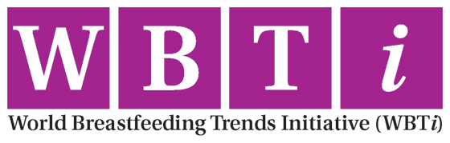

**Press Briefing: The World Breastfeeding Trends Initiative (WBTi), Congratulates Sri Lanka on achieving first “Green” nation status supporting breastfeeding women**

*Sri Lanka scores 91/100 on 10 parameters policy and programmes in support of breastfeeding women, and leading to improved breastfeeding practices drastically.*

**New Delhi, January 9, 2020:** The World Breastfeeding Trends Initiative (WBT*i*) congratulates Sri Lanka having achieved the status of first ever “Green” Nation in supporting breastfeeding women. This is based on its performance on ten indicators of policies and programmes the WBT*i* uses to color- code and rank countries. In an ascending order of performance WBT*i* color codes are Red, Yellow, Blue and Green.

According to WBT*i* Sri Lanka is [number 1 among 97 countries](https://www.worldbreastfeedingtrends.org/wbti-country-ranking.php) who have so far reported.

“Sri Lanka who scored 91/100 earned a green color code, which implies best level of performance. This is the result of persistent efforts since 2005 to pursue improvements. Sri Lanka has demonstrated high level commitment towards health and nutrition of mothers and babies” says Dr. Arun Gupta the global coordinator of *WBTi.* Not surprisingly, Sri Lanka ranks number 1 on the [health and survival sub-index](https://timesofindia.indiatimes.com/india/how-india-lets-down-its-women-on-health-and-jobs/articleshow/72880043.cms) having taken effective steps in this direction.

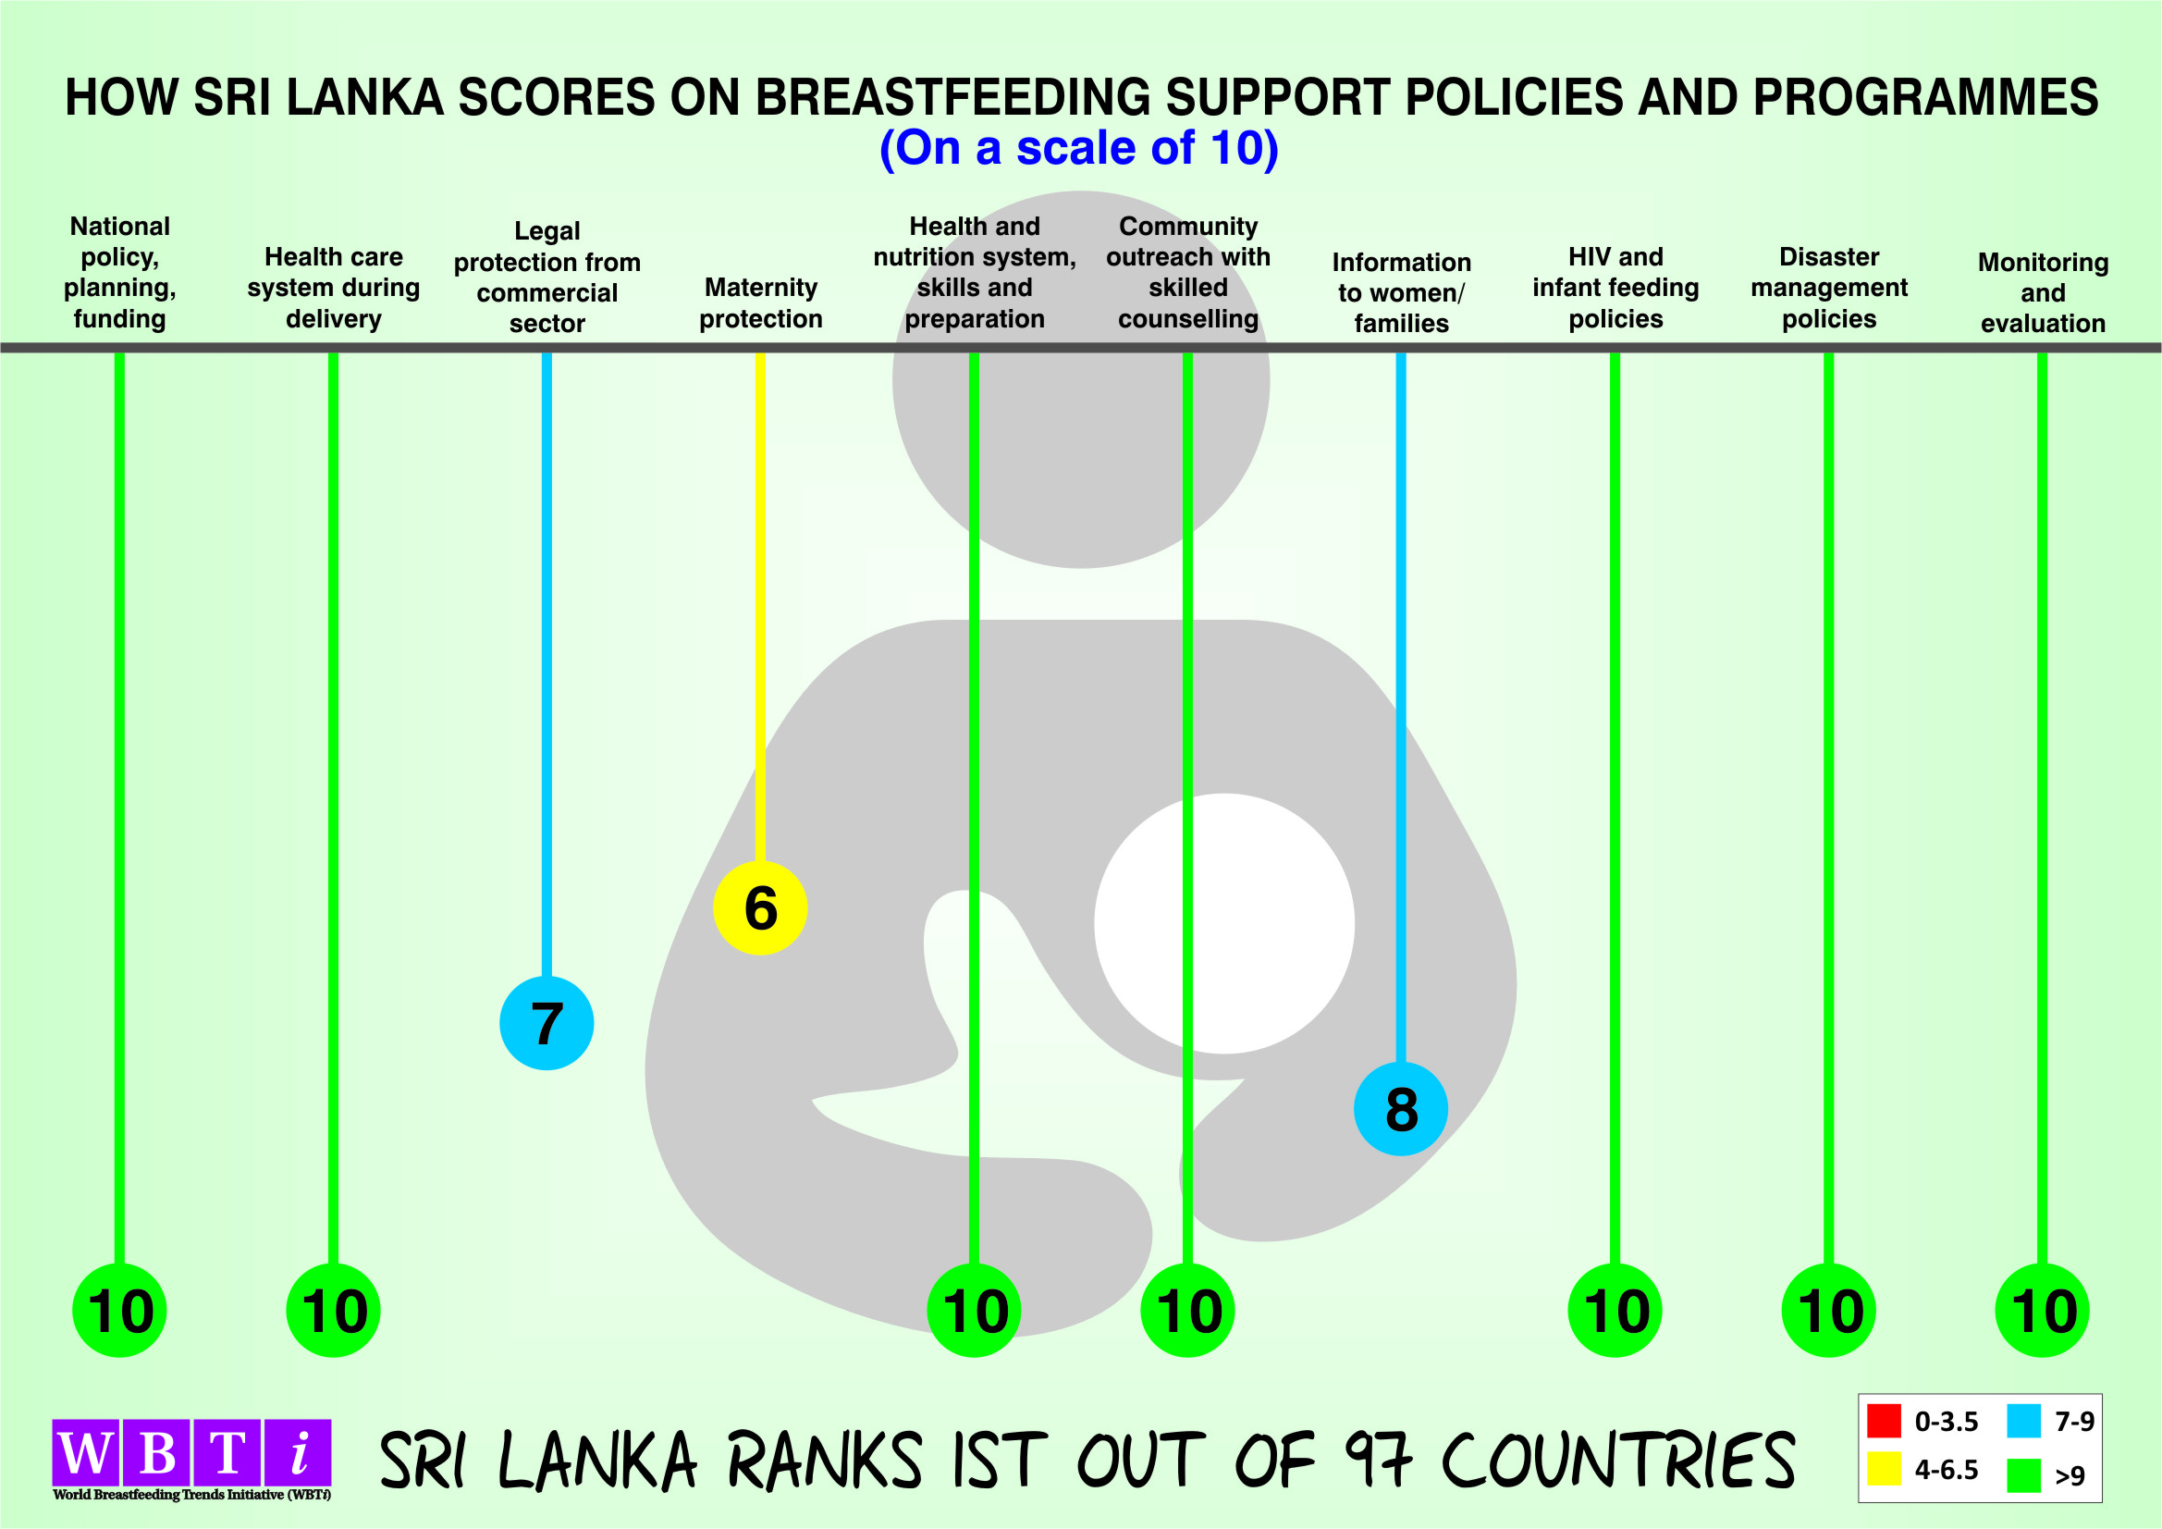

“In 2019, Sri Lanka scored Green code in 7 out of 10 indicators, 2 are in blue and one in yellow. Maternity protection and implementing the International Code of Marketing for Breastmilk Substitutes needs more attention in our country, we want to get green there also” says Wimala Ranatunga, the WBT*i* coordinator of Sri Lanka and President of the Sarvodya Women’s Movement.

Experts at the Breastfeeding Promotion Network of India in Delhi developed the World Breastfeeding Trends Initiative [(WBT*i*)](https://www.worldbreastfeedingtrends.org) and launched it worldwide. So far 120 countries have been involved in WBT*i* and 97 have completed assessments and reported. As WBT*i* expects, many countries have done repeated assessments 2-3 or 4 times since 2005. India and Sri Lanka have done it 5th time in 15 years.

The WBT*i* assists countries to assess and analyse gaps, and then calls for action to bridge the gaps. It has led to development of a [data repository of policy& programmes](https://www.worldbreastfeedingtrends.org/wbti-country-report.php). Alongside, the WBT*i* portal provides scoring, ranking, color- coding of the country performance on 10 indicators of policies and programmes that it measures. The WBT*i* makes this information available to everyone. The WBT*i* process includes re-assessment every 3-5 years as an integral part to check the trends in country. It has been seen that the more countries do re assessment the better are the improvements in policy and programmes/services to women to remove the barriers they face while breastfeeding. These barriers include lack of support by health systems, lack of facilities and break times at work, and aggressive promotion of baby foods by the companies. The WBT*i findings* raise awareness of gaps and generate action to ask the governments and employers to bridge the gaps where needed.

The WBT*i* tools generate color- coded simple graphics, which are easily understandable by the policymakers to identify and prioritize areas for investment. For example if an indicator is in ‘Red’ it needs greater attention. Thus the WBT*i* comes in handy to strengthen a country’s policy implementation and services.

[Inadequate breastfeeding costs the global economy almost $1 billion each day.](https://www.aliveandthrive.org/new-cost-of-not-breastfeeding-tool-launched/) This loss is due to lost productivity and healthcare costs. In addition it saves 700,000 lives annually. Breastfeeding majorly benefits child health, women’s health and prevents non -communicable diseases. This can only be achieved through galvanizing national actions to protect, and support every pregnant and lactating woman.

Globally only 41% of infants of 0-6 months are exclusively breastfed. The World Health Assembly has set a target to reach 50% by 2025, every country should contribute to it. [According to WHO and UNICEF](https://www.who.int/nutrition/publications/infantfeeding/global-bf-collective-investmentcase.pdf?ua=1) every pregnant and breastfeeding woman and the baby require an enabling environment in order to begin breastfeeding within an hour of birth, breastfeed exclusively for 6 months and continue breastfeeding along with adequate foods till 2 years or beyond.

**For more information contact:**

WBT*i* Global Secretariat

BP-33, Pitampura,

Delhi 110034

Dr Arun Gupta

[arun.ibfan@gmail.com](mailto:arun.ibfan@gmail.com)

Nupur Bidla

[nupurbidla@gmail.com](mailto:nupurbidla@gmail.com)

**Notes for Editor**

* **WBTi Global Data Repository**

<https://www.worldbreastfeedingtrends.org/wbti-countries.php>

* **Comparison of India with South Asian countries on the progress on policy and programmes related to breastfeeding and infant and young child feeding**

<https://www.worldbreastfeedingtrends.org/uploads/resources/document/comparison-of-india-with-south-asian-countries.pdf>